1. 
2. ST THOMAS GIRLS’ SEC SCH
3. LOWER SECONDARY LEVEL EXAMINATIONS
4. END OF YEAR 2023
5. ICT
6. SENIOR TWO
7. PAPER 840/1
8. Time: 2Hours
9. Instructions

* attempt any six (6) Questions only
* use of readable and clear handwriting will lead to award of more scores

1. Recently the Uganda Communication Commission (UCC) supplied your school with new computers. However, the technical team that came said that the new computers are vulnerable to threats in your computer laboratory. They advised the school to provide the possible measures to prevent the challenges. the school identified you as an ICT leaner to



1. (i) Explain the possible threats that the technical team said the computers may be vulnerable to in your computer laboratory **(Score 8)**

ii) Explain what can be done to help the school manage the above. **(Score 8)**

1. The computers brought are to be networked, please help the school identify the requirements needed to be used in a network system **(score 4)**
2. Your school intends to buy a new big printer 3 in 1 come next year since the one that they are currently using is very small and cannot manage big jobs. The head teacher intends to travel to Kampala in December for that. However, he lacks knowledge on such device. he called you as one of the leaner taking ICT to explain to him some few things

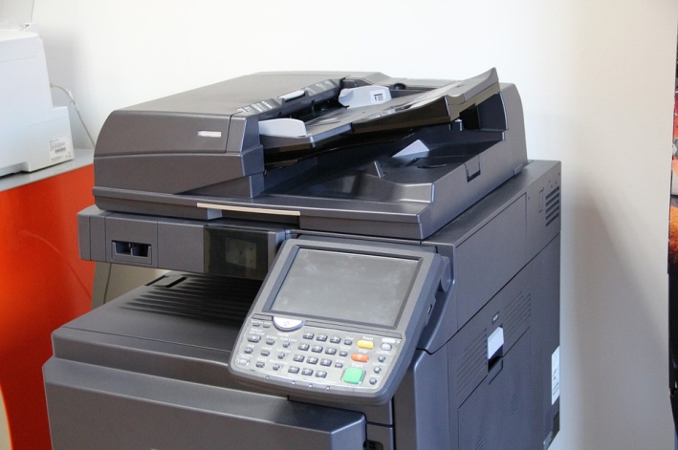

1. Suggest the factors that the head teacher should consider when buying the printer. **(score 6)**
2. Other than the device above, assuming the school wants to buy other output devices which kind of output devices would you suggest for them to buy and why? **(score 10)**
3. How would you keep the above device(s) in good working condition**(score 4)**
4. Your school has just acquired new computers from Uganda Communication Commission and they need to be protected in order to be used for a long period of time. Looking at the current state of your lab.

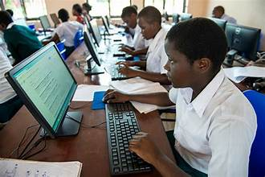

1. State what would be done to keep them safe and in good working condition for a long period of time **(score 10)**
2. Which tools or Equipment are used in servicing and protecting computers

**(Score 4)**

1. What are the threats to computers in your school **(score 6)**
2. When you joined S.1 you were introduced to the subject of ICT by your teacher. you went back home for holidays and met your friend who is in Kobulubulu SS and told you that they have not yet introduced them into the subject but she has interest in the subject

**(a).** Help your friend to differentiate between the following terms and meaning of;

(i). A computer and a computer system **(score 2)**

(ii). Hardware and Software **(score 2)**

(iii). Hard copy and Soft copy **(score 2)**

(iv). Computer Peripherals **(score 2)**

(v). Data and information **(score 2)**

**(b).** Identify and explain the devices and their uses that make up a computer system to your friend **(score 5)**

**(c).** Why is it important to study ICT in secondary schools today? **(Score 5)**

1. The president of Uganda is going to Visit your school. Your head teacher has informed the area Mp (Member of Parliament), the parents and the neighboring schools. In this case the head teacher has shared information about the president’s visit.
2. (i) In the above scenario, which means do you think the head teacher used to share information about the president’s visit with the Mp, the parents and the neighboring schools **(score 10)**
3. Give reasons for your responses above **(score 10)**
4. The head teacher of your school recently told you about the current technological changes. he then advised you to find more about this and share some of your friends



1. Briefly explain what is meant by information Access **(score 2)**
2. in which ways do you access information at school **(score 4)**
3. what are the advantages of accessing information at school **(score 6)**
4. what would you use to access information and share with your friends

**(Score 8)**

1. The bursar of St. Thomas girls’ ss is planning to make a presentation to the parents, and other stakeholders during the meeting in December, he wishes to use any presentation software but has little knowledge. He then approached you as an ICT leaner
   1. (i). Describe to the bursar the meaning of a presentation software **(score 2)**

(ii). List down any three presentation software that the bursar would choose and use for organizing his presentation **(score 3)**

* 1. Describe to the bursar what would make his presentation interesting through the following

1. While designing his presentation **(score 5)**
2. (ii). while presenting his presentation **(score 5)**
   1. Explain to the bursar the advantages and disadvantages of using such presentation software. **(score 5)**
3. 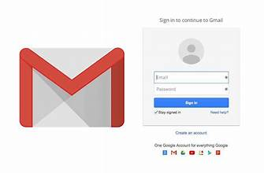The head teacher of Kaberamaido SS suggested to all his staff to have smart phones and register with Gmail services such that the information shall be shared to their inboxes. However, most of the teachers do not know how to use the email services. As a leaner of ICT in St. Thomas girls’ Ss the head teacher identified you and shared with you the scenario, he then told you to organize and go to sensitize his teachers
   1. (i) Describe and explain to the teachers the contents of the email system

**(Score 5)**

1. Describe the processes that the teachers would follow while creating their different accounts **(score 5)**
   1. Share with the teachers the advantages and disadvantages one would enjoy while using the above service. **(score 6)**
   2. Explain to the teachers the code of conduct that they should observe while communicating online. **(score 4)**
2. Hardly a day passes without the use of internet in the modern societies today. Your school Matron recently bought a new smart phone from Gaitano phones and Electronic center-Kaberamaido, she then approached you that her newly smart phone cannot access internet. As an ICT leaner;
   1. (i) Identify any three internet service providers in Uganda that the Matron can choose and use **(score 3)**

(ii). Outline the factors that the Matron can consider while choosing the above internet service provider **(score 5)**

* 1. (i) List any three internet web browsers that the Matron can use **(score 3)**

1. Describe to her the steps of installing one of the web browsers in her new smart phone **(score 3)**

(c). Discuss the advantages and disadvantages of using the internet to the Matron **(score 6)**

***END***

Success and I wish you a happy Merry Christmas and a prosperous new year